Hello and welcome to the Hackathon! Follow the instructions below to setup Kiro and feel free to reach out to an event facilitator if you have trouble.
- Install the AWS CLI to your local machine if you haven’t already – the instructions are available here
  - You can ask Kiro walk you through this by using the chat interface in “Vibe” mode too
- Create a folder in your local machine’s directory
  - You can then open the folder in Kiro and it will act as your workspace i.e. the local directory that Kiro has permission to directly modify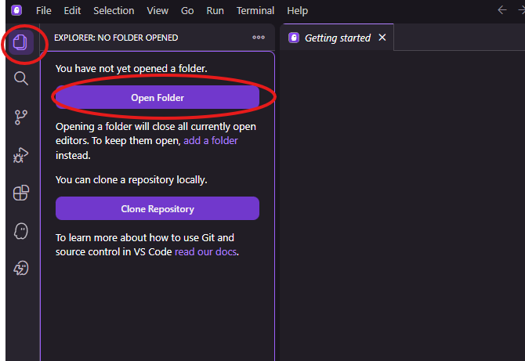
- Download the sample data from the Hackathon repository and place it into the folder you created

- Connect Kiro to the AWS API, IaaC, and Documentation MCP servers
  - Download the mcp.json file from the Hackathon repository
  - In Kiro, navigate to the “Kiro” tab on the lefthand sidebar
  - Select the “Open MCP Config” button
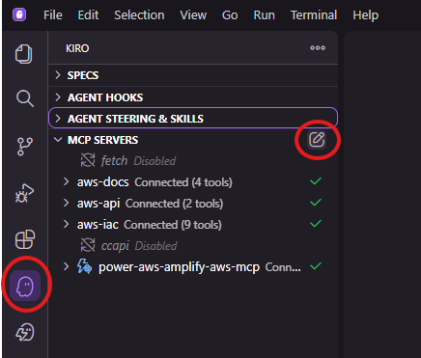
  - Copy the contents of the mcp.json file you downloaded and paste it into the mcp.json file open in the Kiro IDE, then save and close it
  - If you experience an ENOENT error, you may have to install the UV package – paste the error message into your Kiro chat for more information
  - NOTE – if you’ve already been using Kiro and have a preexisting mcp.json config file, ensure you back it up before replacing the contents!

- Get your AWS credentials from the workshop and set them as environment variables in your terminal in Kiro
  - Follow the workshop link and complete the sign-in process, then look for the “Get AWS CLI credentials” link on the left-hand side of the workshop page in your browser
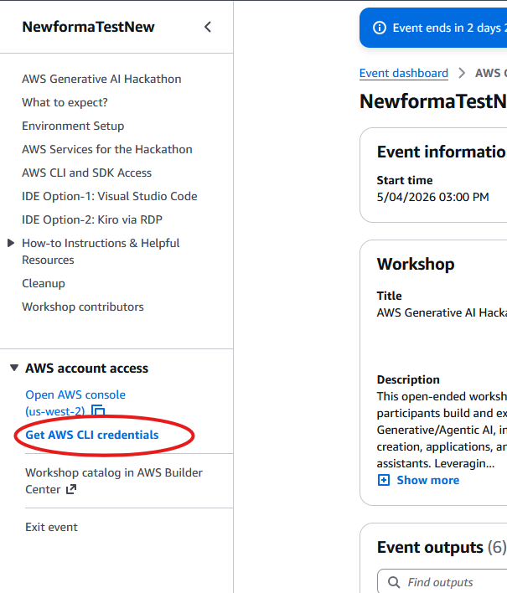
  - Copy the credentials to your clipboard from the pop-up menu

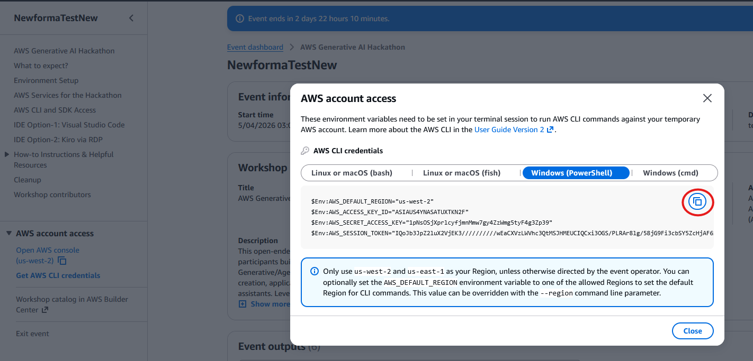
  - Paste the contents of your clipboard into your terminal session to set your credentials as environment variables
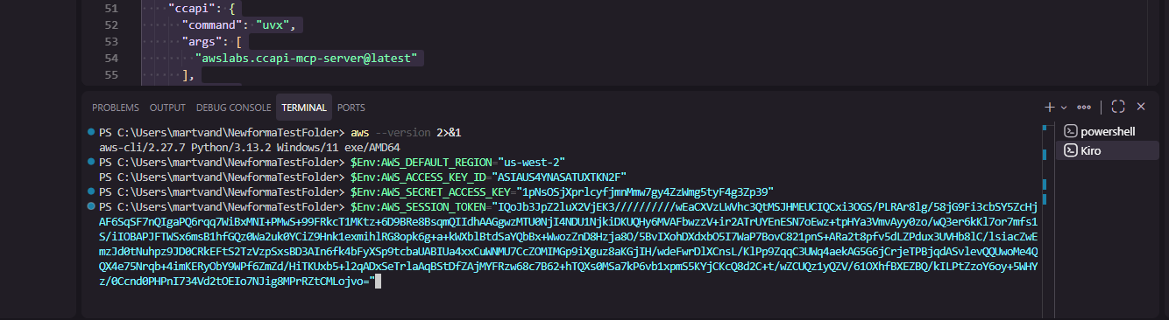

- On the right-hand side, choose the “Spec” development mode and start working through the chat prompts to develop your solution
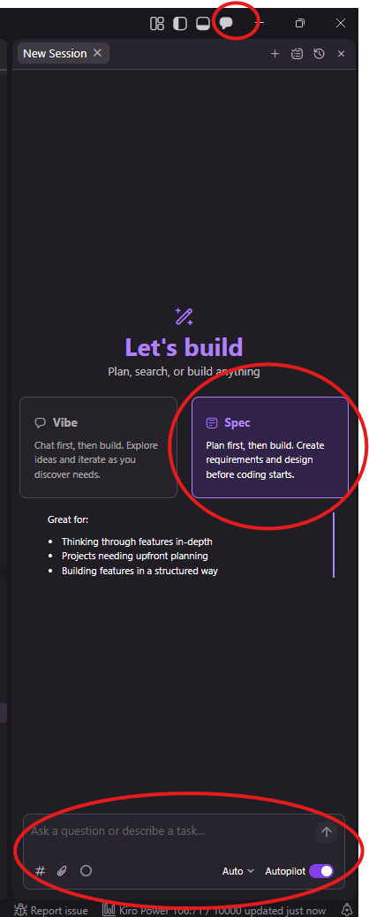
  - From here, you can take any approach you want – copy and paste the entire guideline document, summarize it in your own words, etc. The choice is yours!

Tips and tricks for Hackathon participants:
- You can open extra sessions in parallel with your main spec-driven session and interact with Kiro while it executes in the main session.
- Only the following LLMs are available via Bedrock in the sandbox environment:
  - All Amazon Models
  - Anthropic Claude Sonnet 4.6
  - Anthropic Claude Opus 4.6
  - Meta Llama 4 Maverick 17B Instruct
  - Mistral Pixtral Large (25.02)
  - Stable Diffusion 3.5 Large
If you specify this to Kiro, it can choose models accordingly!
- Kiro may push back when you first try deploying resources, expressing concerns about deploying in a production environment. You can tell Kiro you’re deploying to a sandbox environment, and then it should let you continue.
- The workshop contains valuable information and resources for different AWS services – and you can ask Kiro, too.
- You can ask Kiro to create additional sample data for you if you need it for testing purposes. If you need additional visual media for sample data, ask Kiro to call the Stable Diffusion 3.5 model via Bedrock to help.

